Q1.

-- Create the database

CREATE DATABASE railway_reservation;

-- Connect to the database

-- \c railway_reservation

-- Create the TRAIN table

CREATE TABLE TRAIN (

TRAIN_NO INT PRIMARY KEY,

TRAIN_NAME VARCHAR(20),

DEPART_TIME TIME,

ARRIVAL_TIME TIME,

SOURCE_STN VARCHAR(20),

DEST_STN VARCHAR(20),

NO_OF_RES_BOGIES INT,

BOGIE_CAPACITY INT

);

-- Create the PASSENGER table

CREATE TABLE PASSENGER (

PASSENGER_ID INT PRIMARY KEY,

PASSENGER_NAME VARCHAR(20),

ADDRESS VARCHAR(30),

AGE INT,

GENDER CHAR(1) -- Changed to CHAR(1)

);

-- Create the TICKET table (M:M relationship)

CREATE TABLE TICKET (

TRAIN_NO INT,

PASSENGER_ID INT,

TICKET_NO INT PRIMARY KEY,

BOGIE_NO INT,

NO_OF_BERTHS INT,

DATE DATE,

TICKET_AMT DECIMAL(7,2),

STATUS CHAR(1), -- Changed to CHAR(1)

FOREIGN KEY (TRAIN_NO) REFERENCES TRAIN(TRAIN_NO),

FOREIGN KEY (PASSENGER_ID) REFERENCES PASSENGER(PASSENGER_ID)

);

-- Insert sample data into TRAIN

INSERT INTO TRAIN (TRAIN_NO, TRAIN_NAME, DEPART_TIME, ARRIVAL_TIME, SOURCE_STN, DEST_STN, NO_OF_RES_BOGIES, BOGIE_CAPACITY) VALUES

(101, 'Rajdhani Exp', '17:00:00', '21:00:00', 'Delhi', 'Mumbai', 10, 72),

(102, 'Shatabdi Exp', '06:00:00', '12:00:00', 'Mumbai', 'Pune', 5, 72),

(103, 'Duronto Exp', '22:00:00', '08:00:00', 'Kolkata', 'Chennai', 12, 72);

-- Insert sample data into PASSENGER

INSERT INTO PASSENGER (PASSENGER_ID, PASSENGER_NAME, ADDRESS, AGE, GENDER) VALUES

(1, 'Amit Sharma', '123 MG Road, Delhi', 30, 'M'),

(2, 'Priya Patel', '456 Linking Rd, Mumbai', 25, 'F'),

(3, 'Rahul Singh', '789 Park St, Kolkata', 40, 'M');

-- Insert sample data into TICKET

INSERT INTO TICKET (TRAIN_NO, PASSENGER_ID, TICKET_NO, BOGIE_NO, NO_OF_BERTHS, DATE, TICKET_AMT, STATUS) VALUES

(101, 1, 1001, 1, 2, '2024-01-20', 2500.00, 'C'),

(102, 2, 1002, 3, 1, '2024-01-20', 1200.00, 'C'),

(101, 3, 1003, 2, 3, '2024-01-21', 3750.00, 'W');

-- a) Trigger to validate train arrival time must be less than train departure time.

CREATE OR REPLACE FUNCTION validate_train_times()

RETURNS TRIGGER AS $$

BEGIN

IF NEW.ARRIVAL_TIME >= NEW.DEPART_TIME THEN

RAISE EXCEPTION 'Arrival time must be less than departure time.';

END IF;

RETURN NEW;

END;

$$ LANGUAGE plpgsql;

CREATE TRIGGER check_train_times

BEFORE INSERT OR UPDATE ON TRAIN

FOR EACH ROW

EXECUTE FUNCTION validate_train_times();

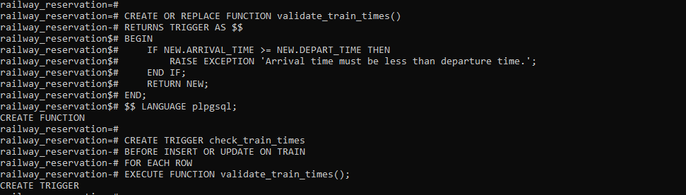

-- b) Trigger to display message 'Ticket is updated' after changing ticket information.

CREATE OR REPLACE FUNCTION display_ticket_updated()

RETURNS TRIGGER AS $$

BEGIN

RAISE NOTICE 'Ticket is updated';

RETURN NEW;

END;

$$ LANGUAGE plpgsql;

CREATE TRIGGER after_ticket_update

AFTER UPDATE ON TICKET

FOR EACH ROW

EXECUTE FUNCTION display_ticket_updated();

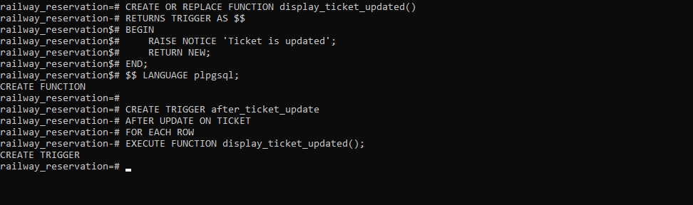

Q.2

-- Create the database

CREATE DATABASE bus_transport;

-- Connect to the database

-- \c bus_transport;

-- Create the BUS table

CREATE TABLE BUS (

BUS_NO INT PRIMARY KEY,

CAPACITY INT NOT NULL,

DEPOT_NAME VARCHAR(20)

);

-- Create the ROUTE table

CREATE TABLE ROUTE (

ROUTE_NO INT PRIMARY KEY,

SOURCE CHAR(20),

DESTINATION CHAR(20),

NO_OF_STATIONS INT

);

-- Create the DRIVER table

CREATE TABLE DRIVER (

DRIVER_NO INT PRIMARY KEY,

DRIVER_NAME CHAR(20),

LICENSE_NO INT UNIQUE,

ADDRESS CHAR(20),

D_AGE INT,

SALARY FLOAT

);

-- Create the BUS_ROUTE table (M:1 relationship - corrected)

CREATE TABLE BUS_ROUTE (

BUS_NO INT,

ROUTE_NO INT,

PRIMARY KEY (BUS_NO, ROUTE_NO), -- Added a primary key

FOREIGN KEY (BUS_NO) REFERENCES BUS(BUS_NO),

FOREIGN KEY (ROUTE_NO) REFERENCES ROUTE(ROUTE_NO)

);

-- Create the BUS_DRIVER table (M:M relationship)

CREATE TABLE BUS_DRIVER (

BUS_NO INT,

DRIVER_NO INT,

DATE_OF_DUTY DATE,

SHIFT VARCHAR(10), -- Changed SHIFT to VARCHAR

PRIMARY KEY (BUS_NO, DRIVER_NO, DATE_OF_DUTY), -- Added a primary key

FOREIGN KEY (BUS_NO) REFERENCES BUS(BUS_NO),

FOREIGN KEY (DRIVER_NO) REFERENCES DRIVER(DRIVER_NO)

);

-- Insert sample data into BUS

INSERT INTO BUS (BUS_NO, CAPACITY, DEPOT_NAME) VALUES

(101, 50, 'Central Depot'),

(102, 40, 'Eastern Depot'),

(103, 60, 'Central Depot'),

(104, 55, 'Western Depot');

-- Insert sample data into ROUTE

INSERT INTO ROUTE (ROUTE_NO, SOURCE, DESTINATION, NO_OF_STATIONS) VALUES

(1, 'A', 'B', 10),

(2, 'C', 'D', 15),

(3, 'A', 'D', 20);

-- Insert sample data into DRIVER

INSERT INTO DRIVER (DRIVER_NO, DRIVER_NAME, LICENSE_NO, ADDRESS, D_AGE, SALARY) VALUES

(1001, 'John Smith', 12345, '1 Main St', 35, 50000.00),

(1002, 'Jane Doe', 67890, '2 Oak Ave', 28, 45000.00),

(1003, 'David Lee', 24680, '3 Pine Ln', 52, 60000.00),

(1004, 'Sarah Kim', 13579, '4 Elm Rd', 48, 55000.00);

-- Insert sample data into BUS_ROUTE

INSERT INTO BUS_ROUTE (BUS_NO, ROUTE_NO) VALUES

(101, 1),

(102, 2),

(103, 1),

(104, 3);

-- Insert sample data into BUS_DRIVER

INSERT INTO BUS_DRIVER (BUS_NO, DRIVER_NO, DATE_OF_DUTY, SHIFT) VALUES

(101, 1001, '2024-01-20', 'Morning'),

(101, 1002, '2024-01-20', 'Evening'),

(102, 1003, '2024-01-21', 'Morning'),

(103, 1001, '2024-01-21', 'Evening'),

(104, 1004, '2024-01-22', 'Morning');

-- a) Trigger to validate driver age before insert or update

CREATE OR REPLACE FUNCTION validate_driver_age()

RETURNS TRIGGER AS $$

BEGIN

IF NEW.D_AGE >= 18 AND NEW.D_AGE <= 50 THEN

RAISE NOTICE 'Valid entry';

RETURN NEW;

ELSE

RAISE EXCEPTION 'Invalid driver age. Age must be between 18 and 50.';

END IF;

END;

$$ LANGUAGE plpgsql;

CREATE TRIGGER check_driver_age

BEFORE INSERT OR UPDATE ON DRIVER

FOR EACH ROW

EXECUTE FUNCTION validate_driver_age();

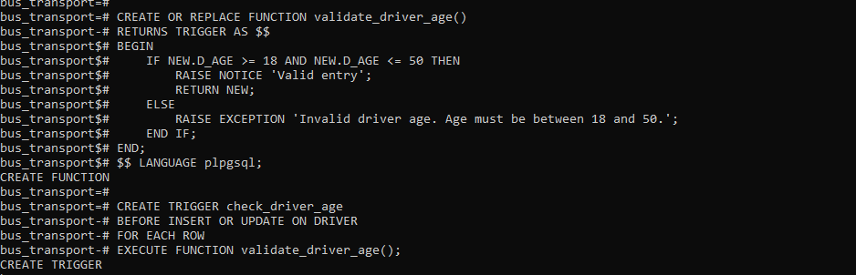

-- b) Trigger to display message after deleting a bus with capacity < 10

CREATE OR REPLACE FUNCTION check_bus_capacity_on_delete()

RETURNS TRIGGER AS $$

BEGIN

IF OLD.CAPACITY < 10 THEN

RAISE NOTICE 'Bus with capacity % deleted.', OLD.CAPACITY;

END IF;

RETURN OLD;

END;

$$ LANGUAGE plpgsql;

CREATE TRIGGER after_delete_bus

AFTER DELETE ON BUS

FOR EACH ROW

EXECUTE FUNCTION check_bus_capacity_on_delete();

